The Executive Director
Australian Law Reform Commission
Email: info@alrc.gov.au

Dear Executive Director,

Traditional Rights and Freedoms – Encroachments by Commonwealth Laws (ALRC Interim Report 127)

Submission with respect to Freedom of Speech and Secrecy Laws
The following notes explain the background information that is necessary to appreciate the points that address Section 16 in relation to Separation of Powers in the abovementioned report.

Background information
I have become increasingly concerned to learn that the ‘Australian Government’ (as it is commonly known) has been operating as an illegitimate government since 1973 when compared to how government should be established in accordance with Australia’s Constitution.
The event that brought about this change occurred when ‘The Royal Style and Titles Act - 1973’ (refer Appendix 1) was established by both Houses of Parliament to remove the Constitutional monarch from the Constitution and replace her with a fictional monarch without any referendum approval being obtained by referendum to do so. This transition meant:
Elizabeth the Second, by the Grace of God of the United Kingdom, Australia and Her other Realms and Territories Queen, Head of the Commonwealth, Defender of the Faith
who was Australia’s natural, living Constitutional monarch then became the fictitious paper entity titled:
Elizabeth the Second, by the Grace of God, Queen of Australia and Her other Realms and Territories, Head of the Commonwealth.
Such an act by the politicians who participated in this event effectively made Australia’s Constitution null and void. Once this and other related legislation needed to transition governmental power away from the people to the politicians was enacted, Australia effectively became a republic, with the CEO of the corporation known as the “COMMONWEALTH OF AUSTRALIA” becoming Australia’s defacto ‘President’.
This submission provides sufficient evidence to establish the claim that successive governments have further corrupted our system of government – from being the Westminster-style of government to a Corporatised-style of government. This means that all Acts created in both houses of the Federal parliament since 1973 are possibly illegal.

Basis to these claims
Diagram 1 illustrates the type of structure the Constitutionally-established Australian Government should be functioning as.
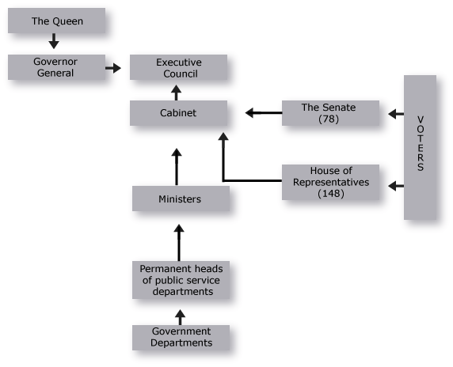
Diagram 1 – Structure of ’Constitutional’ Government in Australia
However, the Members of the two major political parties under an Australian system of government, from or about 5 December 1972, under a progressive evolution, as well as by removing the words “of the Commonwealth” from “The Parliament” and numerous statutes, created their own “Commonwealth” and “Australia”, to be a sovereign, independent and federal nation, with its own “Queen of Australia”, “Australia’s Constitution”, “Governor-General of Australia”, “Great Seal of Australia”, “Australian Government Gazette”, “Australian Citizens”, “Australian Elections”, “Parliament of Australia”, “Australian Government”, “Australian Courts”, “Australian Currency” in “Australian Dollars”, “Australian Law”, all created under their own legislation “of Australia”.
The various acts that enabled this transfer of Constitutional power from ‘We the People’ to the two major political parties to take place were:
- The Commonwealth Electoral Act 1973, No. 7 of 16 March 1973
- The Acts Interpretation Act 1973, No. 79 of 19 June 1973
- The Evidence Act 1973, No. 80 of 19 June 1973
- The Australian Citizenship Act 1973, No. 99 of 17 September 1973
- The Royal Style and Titles Act 1973, No. 114 of 19 October 1973
- The Currency Act 1965-1973, as at 19 December 1973
- The Statute Law Revision Act 1973, No. 216 of 19 December 1973
- The Statute Law Revision Act 1974, No. 20 of 25 July 1974 both No. 216 of 1973 and No. 20 of 1974 that came into operation 31 December 1973
- The Federal Court of Australia Act 1976, No. 156 of 9 December 1976
- The High Court of Australia Act 1979, No. 137 of 23 November 1979
- The Judiciary Amendment Act (No. 2) 1979, No. 138 of 23 November 1979
- The Australia Acts 1986.
The extracts from Australia’s Constitution highlight the true relationship that is supposed to exist between Australia’s Monarch and her Governor General and the Executive Government.

The True Relationship of ‘The Queen’ to the ‘Governor General’
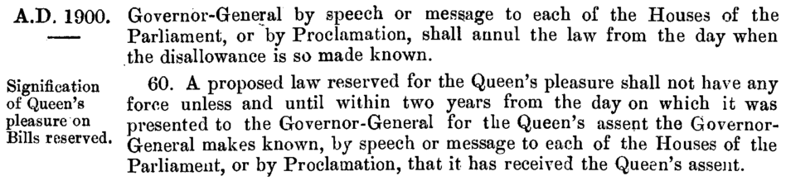

The True Relationship of ‘The Queen’ to the ‘Executive Government’
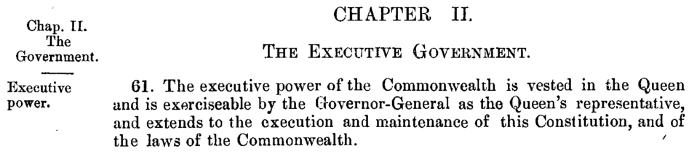
In the above Westminster form of government, individual politicians (not political parties) were to represent their elector’s interests at the national level. In opposition to this, the politicians established a business entity termed the ‘COMMONWEALTH OF AUSTRALIA’ that they registered with the Securities and Exchange Commission for global business purposes to represent their party’s interests.
In other words, the ‘COMMONWEALTH OF AUSTRALIA’ was established to make its owners profits, by encouraging corporations from both Australia and internationally the opportunity to do business in Australia through this entity, as identified below in registration number 0000805157 at the U.S. Security and Exchange Commission.
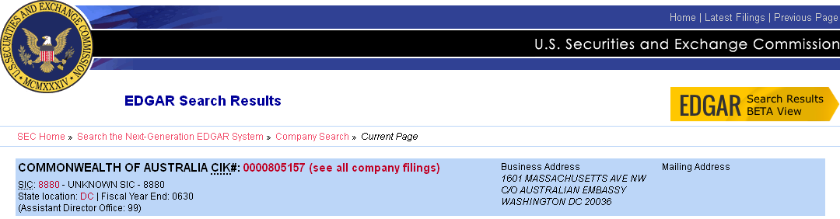

The file named, ‘EX-99.D 3 exhibit_d.htm DESCRIPTION OF THE COMMONWEALTH OF AUSTRALIA’ dated 24 November 2009 found on this website identifies the power structure of this corporatised government:
Quote: “Federal legislative powers in Australia are vested in the Federal Parliament (the "Parliament"), which consists of the Queen [of Australia 1973] as head of state, the Senate and the House of Representatives. The Governor-General represents the Queen [of Australia 1973] throughout Australia.”
Quote: “The executive power of the Commonwealth of Australia under the Constitution is formally vested in the Queen [of Australia 1973] and is exercisable by the Governor-General as the Queen's representative. There is a Federal Executive Council to advise the Governor-General. This Council is composed of the Prime Minister and other Federal Ministers. These Ministers are members of either the House of Representatives or the Senate and generally belong to the party or coalition of parties which has a majority in the House of Representatives. Such Ministers form the Government with the practical result that executive power is exercised by the Prime Minister and the other Ministers.”
Below is a simplified organisational chart that I believe reflects the structure of Australia’s corporatised Federal government as it exists today.
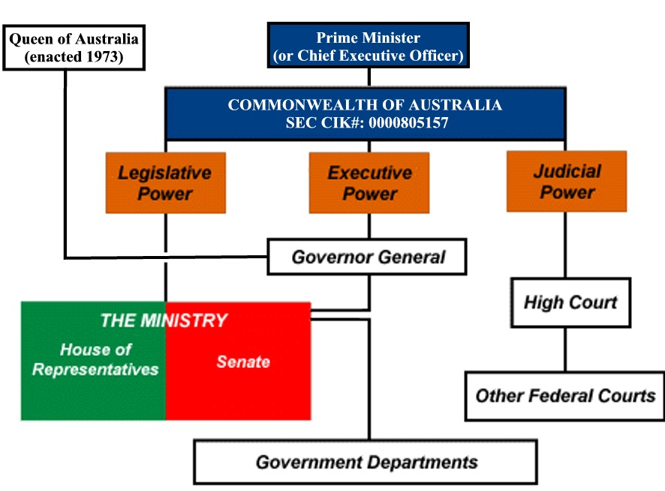

Diagram 2– The ‘Corporatised’ Structured System of Australian Federal Government
The forgoing diagrams (Diagram 1 and 2) illustrate the differences from where governing authority originates and is distributed.
Diagram 1 illustrates that the supreme authority originates with Queen Elizabeth II of Great Britain…and operates to serve the people via the various government entities, as stated in the Constitution.
On the contrary, Diagram 2 illustrates that the fictitious Queen of Australia (enacted 1973) cannot govern, and the Governor General has no authority in which to intervene in the corporation’s activities because “…executive power is exercised by the Prime Minister and the other Ministers”.
To reinforce this claim regarding a ‘powerless’ Governor General in Diagram 2, I wrote to Queen Elizabeth of Great Britain (Appendix 3) requesting her intervention in a matter of mine, and her office on-forwarded my correspondence to the Governor General – Quentin Bryce for attention. A copy of Buckingham Palace’s response to my request can be found in Appendix 2.
The letter received from the Governor General’s Office (Appendix 3) confirmed that her office has no authority to intervene in government affairs, as reproduced in the extract below.
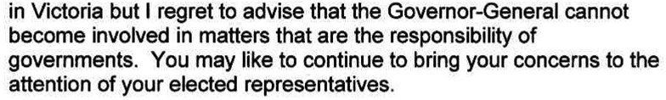
As this lack of governmental authority as defined in the Constitution no longer exists (as admitted by Buckingham Palace and the Governor General’s office), these statements confirm the claims that politicians have corruptly reshaped Australia’s political landscape into a more authoritarian one established as corporate entities – all of which has been done without any referendums being held.
It is not the intention of this submission to try to expose all of the corruption that has occurred to bring this transformation of government about (as the subject matter is highly detailed and is outside the Terms of Reference); nevertheless, a brief example that relates to the establishment of local councils being illegally elevated to ‘Local Government’ demonstrates that this act is in defiance of the Constitution and illustrates the level of corruption that has occurred to Australia’s political systems over many decades.

The illegal means by which ‘Local Government’ was introduced
During the 1986 Federal Election, a referendum was held for voters to decide whether to have Local Government recognised in the Constitution. A summary of the results of the referendum are shown below.
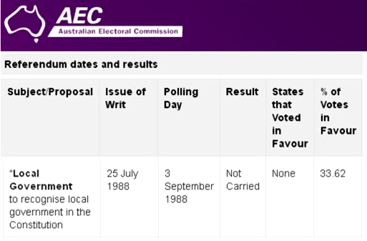
Despite the referendum declaring that two-thirds of Australians did not want local councils recognised as ‘Local Government’, the Hawke Labor Government illegally introduced ‘The Local Government Act 1989’ into all States of Australia the following year, although it was not introduced into some States until 1993.
Since then, Federal, State and local councils have reaffirmed (when challenged) that they operate legally, and base this claim upon the abovementioned Act, however these claims are entirely false if the Constitution is used to determine legality or not.
Appendix 4 contains a copy of a letter dated 8 July 2010 written by Senator Robert McClelland, Attorney General in the former Rudd Government that provided a response to a constituent’s clarification on the legality of Local Government.
In his letter, the Attorney General confirmed that “The Constitution does not currently recognise Local Government”.
The purpose of raising this matter is to demonstrate that the main political parties in Australia have no regard for the Australian Constitution 1901 when it comes to issues involving Local Government, as their corporate structure does not allow for democracy to be determined by ‘We the People’ through referendum, as required in s.128 ‘Alteration of the Constitution’.
In recent times, worse things associated with ‘Local Government’ have come to pass where the Melton Shire Council was granted its request to be termed a “State”, presumably to avoid paying tax to the Australian Taxation Office. Refer Appendix 5 for a copy of the Federal Court’s decision in this matter.
The Order makes reference to s.114 of the Constitution upon which the application was granted. However, s.114 states “consent of the Parliament” is required for this to happen; which I believe has not happened:
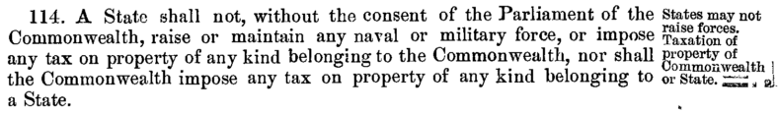
For a Federal Court judge to approve the application without the matter first being heard by both Houses of Parliament or being put to the people of the Commonwealth in a referendum – such an act raises questions as to the legal basis of his decision; as it means that Melton is now a separate State within Australia, a shown in red on the map below.
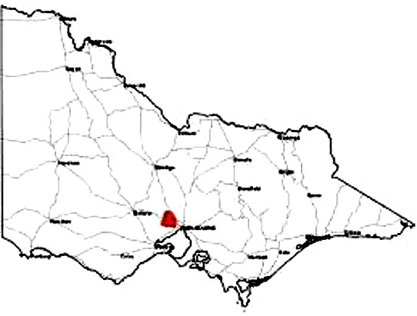
The State of Melton (in red)
ASIC records the Melton Shire Council is a corporation (ABN 22 862 073 889). It therefore makes one wonder why a Federal Court judge would allow a corporation to become a “State” in the same manner as Victoria, Queensland etc. are ‘States’ within Australia’s Constitution.
With the foregoing inconsistencies occurring with Constitutional Government compared to Corporate Government; this raises the issue as to how the continual abuse of Constitutional Law has been allowed to occur in this country since 1973 and why the judiciary have not reacted to this abuse of the Constitution by the politicians.
Therefore, a case could be argued that all legislation that has been enacted in Federal, State and ‘Local’ governments is illegal since that time.

The ‘Separation of Powers’
In view of the foregoing claims and the evidence provided in the appendices, my claims as to “Freedom of Speech and Secrecy Laws” relate to the Chapter 16.1 and 16.2 of the ALRC Interim Report titled, ‘Separation of Powers’.
The following comments illustrate using the foregoing comments that separation between the Constitutional Monarch and the Constitution’s Governor General and the Executive Government does not exist as the ALRC’s Interim Report 127 seems to indicate. This claim is established in the numbered points below.
- Australia’s Constitutional Monarch no longer exists:
- Buckingham Palace confirms ‘The Queen’ “…acts through her personal representative, the Governor-General”.
- The Governor-General confirms that she “…cannot become involved in matters that are the responsibility of governments.”
- A fictional monarch exists in the form of paper titled, ‘The Royal Styles and Titles Act – 1973’ that confirms the Queen Elizabeth of the United Kingdom and Australia’s Governor General have no legal authority in the Australian Government.
- No referendum was held with the Australian people to legally allow this transition to occur.
- An illegal Corporatised form of government has replaced the Constitutionally-established style of Westminster government:
- The corporation’s registry with the U.S. Security and Exchange Commission proves this claim.
- The above statements by the Queen and the Governor-General prove that these people have no Constitutional authority; and the Queen has silently abdicated her Constitutional authority along with the Governor-General’s office by transferring their authority to where “…executive power is exercised by the Prime Minister and the other Ministers”..
- The transformation of local councils to become ‘Local Government’ is illegal:
- Sixty-six percent of the voters in the 1988 referendum said ‘No’ to ‘Local Government’, which meant the parliament had no mandate to proceed with this motion.
- Despite this legal hurdle, the parliament established ‘The Local Government Act 1989’ without the legal right to do so.
- Abuse of the Constitutionally-established Separation of Powers appears to be an ongoing process:
- When a Federal Court judge decrees that a shire council can become a “State” (whether it is for taxation purposes or not) tends to indicate an abuse of Australia’s Constitutional system has taken place.
- This apparent abuse appears to be magnified because most shire councils throughout Australia are corporations associated with ABN numbers. Therefore, to establish a corporation that is commonly recognised as the ‘Third Tier of Government’ to now become a constitutionally-established “State” raises many questions.
e.g. ABN 22 862 073 889 – Melton Shire Council
It is therefore my belief that although the Governor-General, the Prime Minister and the politicians masquerade that Constitutional Government exists and that the separation of those powers exists, the evidence presented here indicates that there is no separation of these powers, because Corporatised Government cannot function effectively unless it has power over all the agencies within government – the Monarch, the Executive and the Judiciary.
It is my recommendation that this matter be brought to the attention of Senator the Hon George Brandis QC, Attorney-General of Australia for him to investigate the claims made here and for him to take the appropriate action to remedy the situation.
Yours sincerely,

Alan Manson

Appendix 1

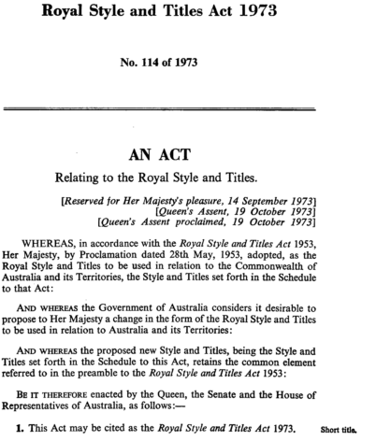

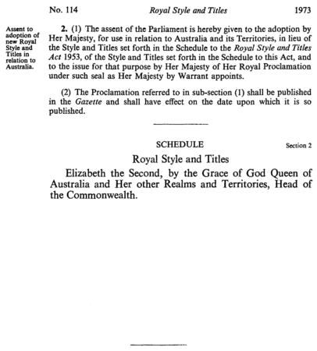

Appendix 2 – Response from Buckingham Palace
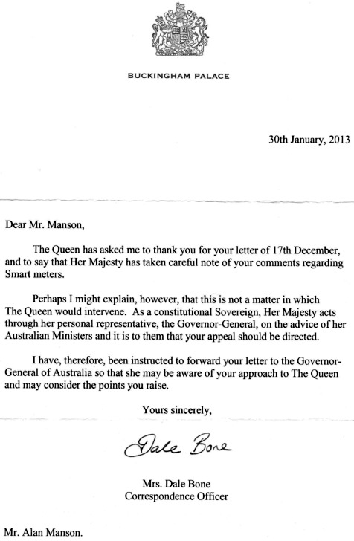

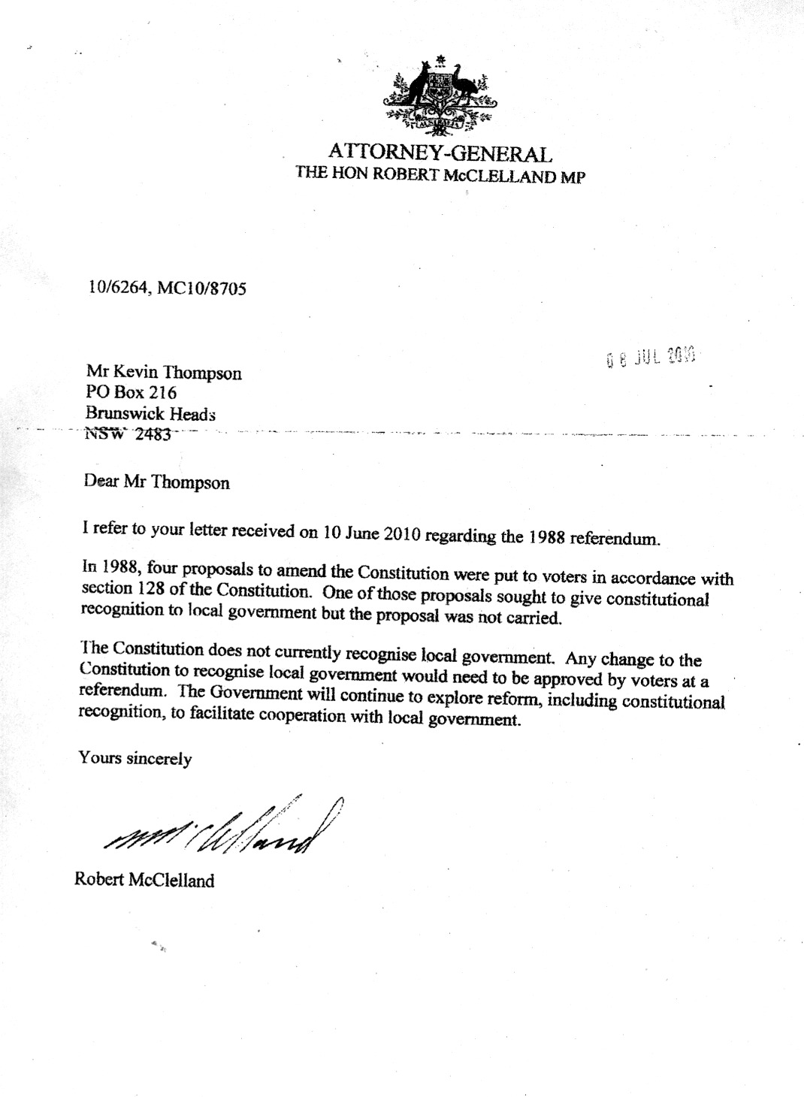

Appendix 3 – Response from Governor General
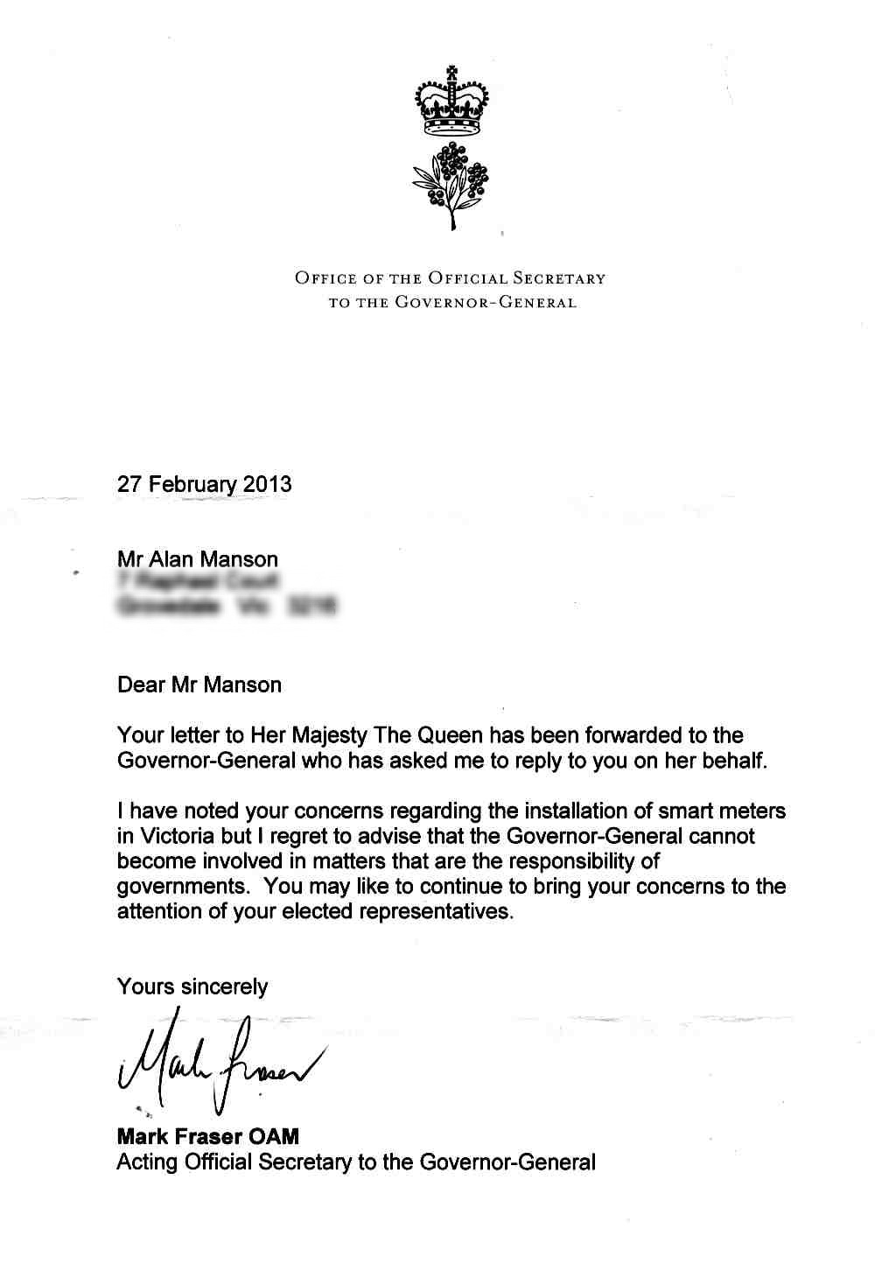

Appendix 4 – Attorney General’s Comments

Appendix 5 – City of Melton now a ‘State’

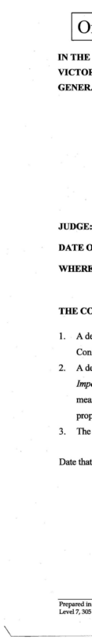
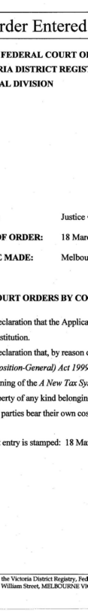
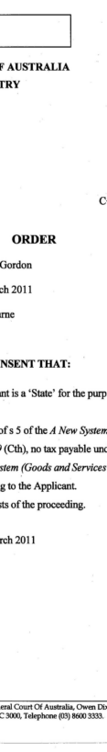
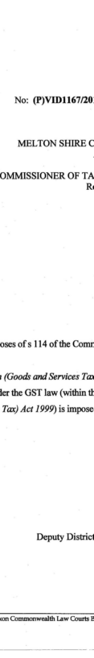
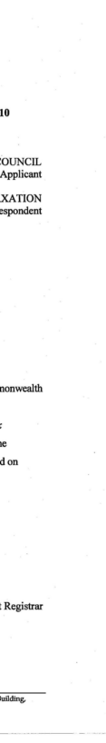

Royal Style and Titles Act 1973 – Exhibit 1
http://www.sec.gov/Archives/edgar/data/805157/000134100409002335/exhibit_d.htm
http://etraining.communitydoor.org.au/mod/page/view.php?id=49
http://www.australiatravelsearch.com.au/trc/law.html (modified)
http://www.aec.gov.au/elections/referendums/Referendum_Dates_and_Results.htm
http://www.restoreaustralia.org.au/are-councils-legal/
http://abr.business.gov.au/SearchByAbn.aspx?abn=22862073889

