Equality, Capacity and Disability in Commonwealth Laws:

Submission

Introduction

- The ACTU is the peak body for working Australians, representing 47 unions and almost two million union members, along with their families.
- The ACTU welcomes the opportunity to provide a written submission to the Australian Law Reform Commission’s review into Equality, Capacity and Disability in Commonwealth Laws.
- The union movement has been a longstanding advocate of people with disability (PWD), since our adoption of the Disabled Workers Charter at the ACTU Congress in 1981. We believe that all workers, including those with disability, should be afforded the opportunity to participate in society on an equal basis, through decent and meaningful work where capable.
- While the inquiry raises a number of salient questions with regards to the equal recognition of people with disability before the law, in our submission we focus specifically on matters relating to discrimination, general protections, superannuation and employment, as being areas of particular importance to our affiliates and their members.

Anti-discrimination law
- The Disability Discrimination Act 1992 (‘the DDA’) has been a fairly effective tool in prohibiting discrimination against people with disability. However, at present, the laws against discrimination vary from state to state, with a range of Commonwealth and state provisions in relation to the regulation of this area. It is our view that having multiple pieces of regulation creates an unnecessary overlap across jurisdictions and can lead to inconsistencies in the way the laws are enacted. The ACTU, along with a wide range of other stakeholders, has consistently endorsed the consolidation and harmonisation of anti-discrimination laws across jurisdictions. It is disappointing that, despite a broad consensus across different groups in relation to the need for harmonisation of anti-discrimination laws, this still has not occurred.
- In considering the harmonisation of anti-discrimination law, we would argue that this process should not undermine any existing rights currently provided for in state or federal legislation. In general, the aim of such a process should be to lift anti-discrimination standards, in line with the high community expectations in this area, rather than resorting to a series of trade-offs such that members of the community end up worse off than they were prior to consolidation. Moreover, if the DDA is to replace all existing state and territory laws, it will need to be amended first to take into consideration various aspects of anti-discrimination law that is covered by the states but not by Commonwealth legislation.
- As part of this consolidation process, there should be broad and extensive consultation among all community stakeholders, including specific consultation directly with the PWD community. It would be a mistake to rush through laws or disallow state and territory laws in the absence of prior consultation, and without first strengthening the Commonwealth provisions to ensure that no one is left behind in the process.
- The harmonisation process could also be used as an opportunity to address a number of areas where the DDA could be enhanced or improved. In particular, we recommend a review of the DDA’s definition of disability; further clarification in relation to the assessment of capacity; and improving the provisions around reasonable adjustments in the workplace.
- This review provides an opportunity to review and update the definition of disability under the DDA in line with internationally accepted standards, which have changed drastically since the DDA was legislated in 1992. The DDA definition of disability is:
- total or partial loss of the person’s bodily or mental functions; or
- total or partial loss of a part of the body; or
- the presence in the body of organisms causing disease or illness; or
- the presence in the body of organisms capable of causing disease or illness; or
- the malfunction, malformation or disfigurement of a part of the person’s body; or
- a disorder or malfunction that results in the person learning differently from a person without the disorder or malfunction; or
- a disorder, illness or disease that affects a person’s thought processes, perception of reality, emotions or judgment or that results in disturbed behaviour;
- and includes a disability that:
- presently exists; or
- previously existed but no longer exists; or
- may exist in the future (including because of a genetic predisposition to that disability); or
- is imputed to a person.
- Unfortunately, this definition of disability draws upon an outdated medical model that assumes that a person’s disability is solely caused by a physical impairment or medical condition, which underpins an assumption that a disability is an internal condition, rather than an external one.
- Many researchers argue that disability is a social construct, merely arising as a result of societal restrictions that act as a barrier to social inclusion. From this perspective, disability is more the result of environmental or social factors rather than something internal to a particular individual.
- There are several international examples that the government could draw upon for a more comprehensive and up-to-date definition of disability under the DDA. For example, the International Labour Organisation in its code of practice on managing disability in the workplace defines a disabled person as “an individual whose prospects of securing, returning to, retaining and advancing in suitable employment are substantially reduced as a result of a duly recognized physical, sensory, intellectual or mental impairment”.
- The United Nations Convention on the Rights of Persons with Disabilities, to which Australia has been a signatory since 2007, provides a much more comprehensive definition than the DDA. The UNCRPD draws upon a social model of disability that emphasises the social barriers that result from society’s inability to effectively manage impairment. In their definition, people with disability are:
those who have long-term physical, mental, intellectual or sensory impairments which in interaction with various barriers may hinder their full and effective participation in society on an equal basis with others.
- This definition acknowledges both the physical and social causes of disability. The government should consider drawing upon the UNCRPD’s definition in developing a more comprehensive definition of disability than that which is currently found in the DDA.
- The assessment of capacity in relation to wages has been a matter of contention following a December 2012 Federal Court case. In Nojin v Commonwealth of Australia [2012] FCAFC 192 (21 December 2012), a full bench majority found that the Business Services Wage Assessment Tool (BSWAT) breaches the DDA in relation to workers with an intellectual disability. The BSWAT is the most frequently used tool within the supported employment services (SES) sector, and is commonly used by Australian Disability Enterprises (ADEs, formerly known as sheltered workshops) to assess the wage levels of workers in the supported employment system.
- The Nojin decision found that two ADEs were in contravention of the DDA as a result of their use of the BSWAT, which relies on competency assessment, to assess wage levels. Workers with an intellectual disability are particularly disadvantaged by competency assessments when compared with workers with a physical disability. As the Nojin decision demonstrates, this amounts to indirect discrimination of workers with an intellectual impairment. These workers are already paid significantly low wages, often around $2 an hour, and workers are unable to request a wage increase unless they meet a range of core and industry competencies which are often irrelevant to the work they actually do.
- The ACTU would strongly oppose any amendments to the DDA that would allow for ADEs to discriminate against workers with an intellectual disability, and supports a legal framework that provides for workers with intellectual and physical disabilities to be assessed in ways that are fair to both. In particular, we agree with the views of Justice Buchanan that section 45 of the DDA, which provides for ‘special measures’ to discriminate if it affords people with disability access to opportunities that they would not otherwise receive, is not intended to allow for ADEs to pay workers with an intellectual disability less, just so that they can maintain their employment at the current low rates of pay.
- More broadly, in a previous submission in relation to improving the employment participation of people with disability, the ACTU recommended the establishment of an employment equity scheme that would operate in a similar manner to the Workplace Gender Equality Agency, by requiring large employers to report on their measures to enhance the participation of PWD in the workforce. As part of this scheme, we would like to see employers develop an employment equity plan that outlines, among other measures, how the employer will accommodate any requests for special assistance or adjustments.

General protections provisions
- The general protections provisions under the Fair Work Act 2009 (‘the FW Act’) relevantly provide that employees, or potential employees, cannot suffer from any adverse action on the grounds of disability. Although similar provisions may be found in various anti-discrimination legislation, it is appropriate that the FW Act also protect against workplace discrimination, to allow such matters to be heard within an industrial context and resolved promptly and at low cost through the Fair Work Commission (including as recently amended to provide for consent arbitration).
- There has been some debate around the onus of proof for general protections claim. Under the current system, if an allegation is made that adverse action was taken for one of the proscribed reasons (such as discrimination), the claimant must prove that the action took place (or was threatened etc) and that it is (or would be) adverse action as defined. However, it is presumed that such action was taken for the proscribed reason unless the defendant proves otherwise. This is consistent with the proposition that defendants should be required to prove matters which are peculiarly within their own knowledge (which is also reflected in the “unjustifiable hardship” provisions of the DDA). The ACTU would strongly oppose any move to legislate away from the general protections provisions as they currently stand in this regard. If the burden of proof were shifted from the employer to the employee, it would enable employers in many cases to escape liability for unlawfully discriminating against an employee with disability merely by pleading non admissions concerning their state of mind.
- In 2012, the general protections provisions were amended to reduce the time limit for lodging an unlawful termination claim from 60 days to just 21 days. This is a very short time limit in which to make a claim. Workers with disability are particularly vulnerable to missing this deadline, as they may not be as aware of their rights and/or may face particular barriers in filing a claim. For this reason, it is recommended that the previous time limit of 60 days be restored for those workers.
- We also note with some concern that the legal effect of section 351(2) of the FW Act is far from certain and it is arguable that if particular adverse action would be lawful under either State or Commonwealth anti-discrimination law, it is not actionable under the FW Act regime. To the extent such a proposition is arguable, amendments ought to be made close this loophole.

Employment
- The ACTU, along with the LHMU (now United Voice), was involved from the earliest days in establishing the Supported Wage System, so that workers with disability could have their employment recognised under the industrial relations system, and protected by the same laws and employment standards as other workers. Prior to this, workers with disability existed outside the industrial relations system and were afforded few of the legal rights that workers without disability enjoyed.
- However, in practice, people with disability may still find themselves being treated as second-class citizens in their employment. Workers with disability in open employment are usually reliant on the same modern award system as other low-paid workers, and should be afforded access to the same conditions of employment as workers without disability. This includes provisions in relation to public holidays, leave, penalty rates, and various provisions under the National Employment Standards. Where a person with disability is engaged in employment, special attention should be given to ensure they understand their workplace rights and conditions. The government may wish to consider an education campaign or similar to address this issue, and ensure that educational materials available through the Fair Work Ombudsman and other government agencies are written in plain English so that they are easily understandable.

Social security, financial services and superannuation
- Compulsory superannuation is an important workplace entitlement which the union movement and ACTU fought strongly to establish. It is a form of ‘deferred wages’ that employees have earned through their labours.
- Many workers with disability are denied access to these deferred wages, as a consequence of their very low wages. Under the current system, employees must meet a minimum earnings threshold of $450 a month before their employer is required to make compulsory superannuation payments. Our position is that this threshold should be abolished. The very low supported wages which many workers with disability are paid means that they are among the groups disadvantaged by it.
- Carers of disabled persons, including those in receipt of the Carers Allowance (who may have some paid employment) and the Carers Payment (who almost universally have no paid employment) ought also to receive superannuation contributions in association with those payments (and their small amount of paid employment, if any) to ensure their financial capacity beyond the period they are able to provide care personally. Failure to fund such contributions merely adds to deferred costs as the carer population ages.
- Life expectancy is generally lower for people with particular disabilities, and as such, PWD should receive early access to their superannuation funds. The ACTU would strongly support amending the preservation age at which a person with disability can access their retirement savings. The exact age should be determined in consultation with people with disability, and could be decided on a case-by-case basis depending on the nature of the employee’s disability. We recognise that some superannuation funds permit the release of accumulated benefits if the fund member also qualifies for particular payments available through fund based insurance, but these provisions are only applicable to persons who sustain a disability after joining the superannuation fund.

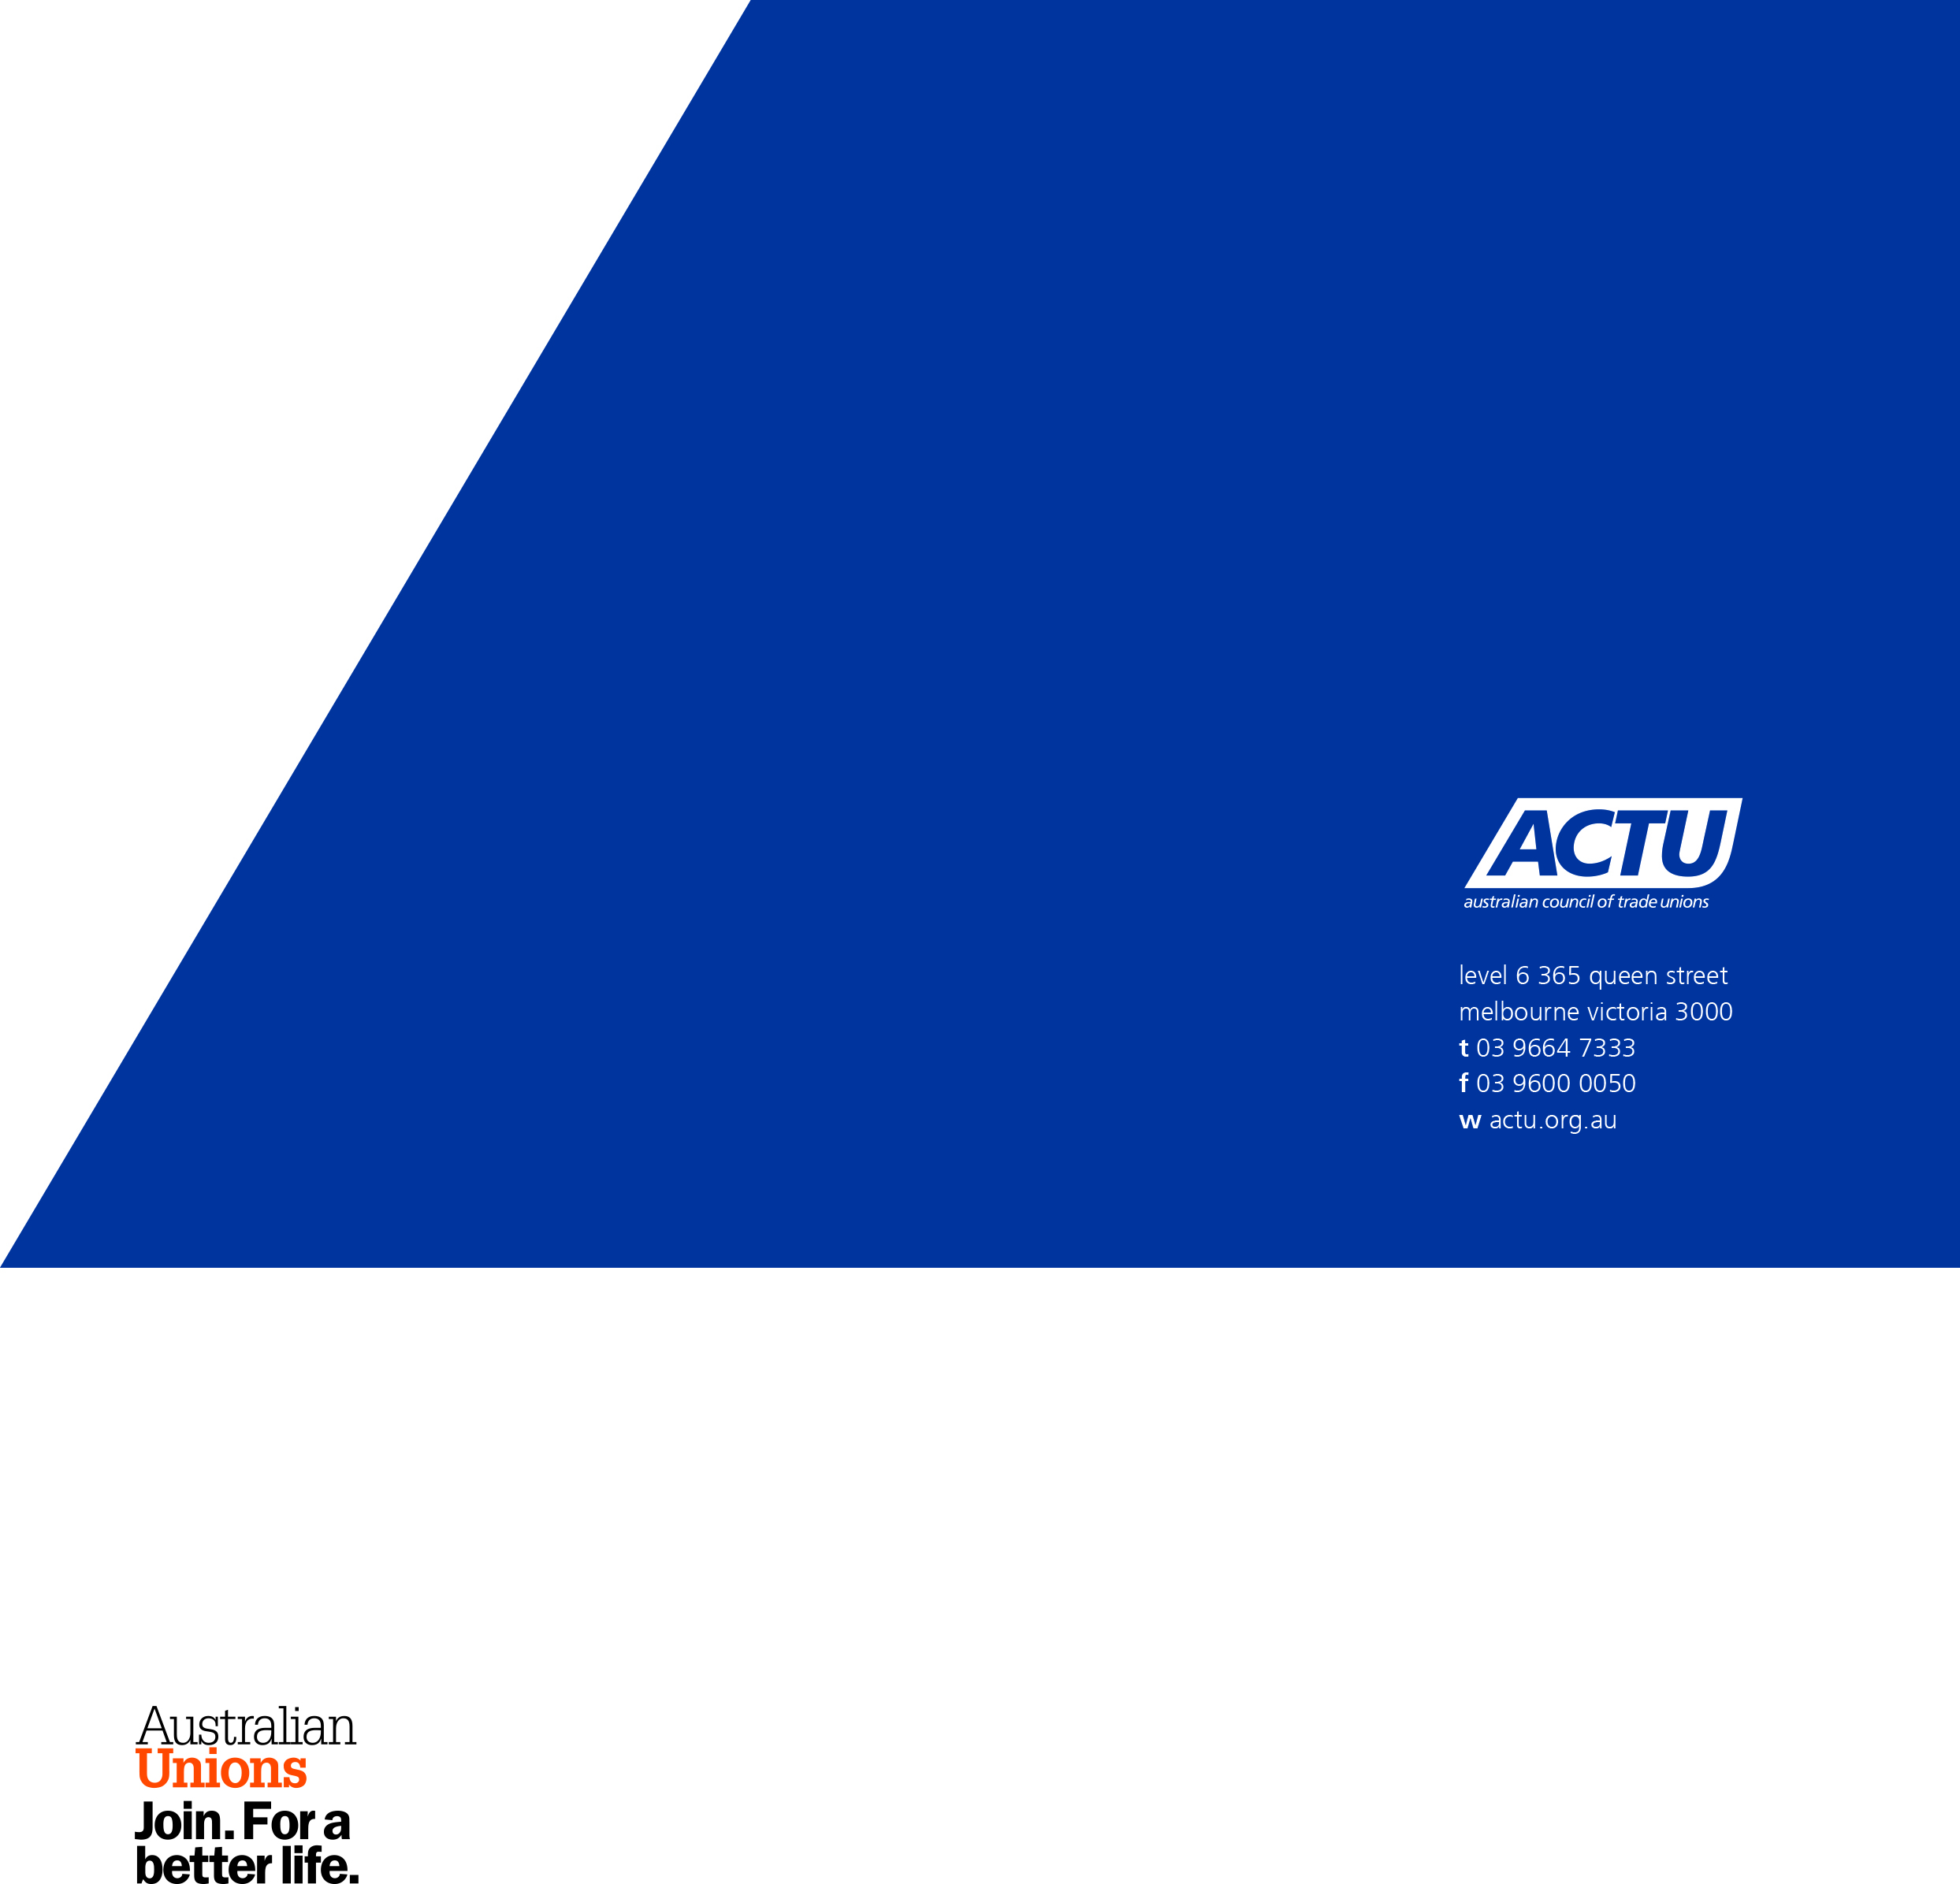
D No. 07/2014

Department of Education and Training, Case studies of employees with a disability, 2005
International Labour Organisation, Managing disability in the workplace: ILO code of practice, 13 February 2002.
Article 1, United Nations Convention on the Rights of Persons with Disabilities
It is now settled that discrimination in this context includes indirect discrimination: Klien v. MFESB [2012] FCA 1402

