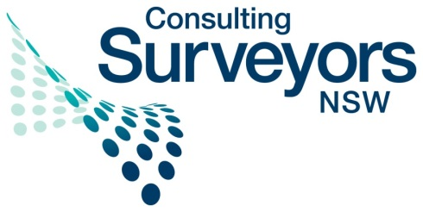
Association of Consulting Surveyors NSW Inc.
Level 10, 99 Bathurst Street, Sydney 2000
PO Box A1155, Sydney South, 1235
Tel: (02) 9267 9728
Fax: (02) 9267 9226
Email: admin@acsnsw.com.au
www.acsnsw.com.au

ABN 67 174 505 197

29 July 2013

Executive Director
Australian Law Reform Commission
GPO Box 3708
SYDNEY NSW 2001

Via email: info@alrc.gov.au

Submission to the review Copyright and the Digital Economy

ACS NSW is an industry body representing over 200 consulting surveying firms working in the area of land development, including the creation of survey plans and other documents that are registered or deposited with government bodies.

Our members strongly oppose the proposals in the ALRC’s recent Discussion Paper to repeal the government statutory licence and to introduce a new exception that would allow free use of our plans for public administration. We are also extremely disappointed in the lack of acknowledgement of the surveyors’ position in the Discussion Paper.

In addition our members are of the opinion that the ALRC’s proposals will create an environment of uncertainty which will require litigation to resolve, as even the ALRC acknowledges. The proposals will have significant impacts for businesses like those of our members in that they will have to monitor use of their intellectual property themselves and enter into litigation where they consider the use is not “fair use”.

Surveyors have recently received a determination from the Copyright Tribunal of Australia, which entitles them to a fair share of money received by the NSW government from sale of their plans. It has taken the profession 16 years to receive recognition of the value of its work, and its entitlement to recompense from the commercial sale of the plans that are created. We do not want to stop governments using surveyors’ plans, and we are not seeking payment for every use of such plans by governments, but we think it is fair that surveyors receive a royalty when the government sells the plans on a commercial basis.

Yours sincerely,
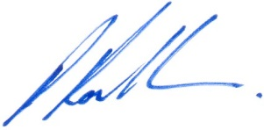
Paul Rowlandson
ACS NSW Chairman

