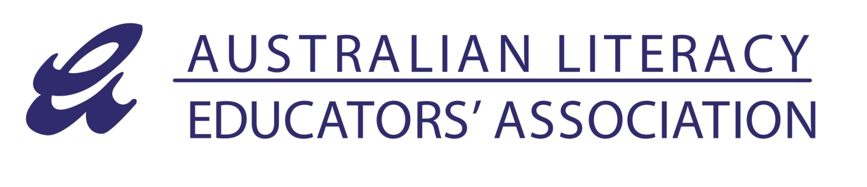
31 July 2013

The Executive Director
Australian Law Reform Commission
GPO Box 3708
SYDNEY NSW 2001

info@alrc.gov.au

SUBMISSION IN RESPONSE TO DISCUSSION PAPER: COPYRIGHT AND THE DIGITAL ECONOMY

The Australian Literacy Educators’ Association (ALEA) is an independent not for profit professional teacher association dedicated to literacy and English language learning and teaching from early childhood through all stages of schooling and tertiary education contexts. ALEA recognises the critical role literacy plays in learning and communicating in all curriculum areas, and for effective participation in society. The Association has 2,000 direct individual and institutional members, and represents almost 4,000 teachers and academics.

ALEA provides leadership, advocacy for teachers, supports teacher professional learning and standards, and publishes and disseminates publications and resources specifically designed for Australian literacy educators.

ALEA achieves its objectives by showcasing Australian and international best practice in literacy education at our annual national conference and through a program of professional learning events that are held throughout Australia at a regional level.

ALEA publishes three journals, three times a year: the Australian Journal of Language and Literacy which is a highly regarded, peer reviewed professional journal; Literacy Learning: the Middle Years and Practically Primary. These latter two journals provide shorter reflections and examples of teachers’ plans and students’ assessment. The journals share current research, highlight trends in teaching and bring international and national best practice to the fore as well as showcasing classroom practice by Australian teachers and educators.

ALEA publishes occasional titles that are specific to the Australian curriculum and are created by ALEA members who are classroom practitioners or working with classroom practitioners. In recent years, ALEA has made increasing use of digital technologies to provide members with access to resources such as newsletters and sample articles from journals.

Income received from the Copyright Agency for copying and sharing of ALEA material is directed back into the production of professional learning resources.

The current Educational Statutory Licence system supports ALEA’s commitment to providing high quality professional learning and resources. Currently, for a minimal cost and without worrying about copyright permissions, delegates and presenters at conferences and professional learning events, and teachers in classrooms at a school and tertiary level, are able to share resources in ways that enhance professional educational practice. This means Australian teachers and students have unparalleled access to high quality educational resources - and at the same time creators earn income which helps to drive the creation of innovative, quality educational content and professional resources.

ALEA SUBMISSION TO ALRC IN RESPONSE TO DISCUSSION PAPER: COPYRIGHT AND THE DIGITAL ECONOMY – Page 2 of 2

We understand a recommendation has been made to remove the current system and replace it with a combination of new arrangements, many of which are voluntary and will create both cost and time burdens and uncertainty for schools, individual teachers and for professional associations such as ALEA.

While the association recognises the growth of the digital environment, and the widespread use of digital technologies on Australian educational institutions, ALEA is very concerned about these proposed changes to Copyright Law, in particular Part 6 -Statutory Licences and Part 13-Educational Use. Changes in these areas will directly affect the work of the Association in creating resources, as well as the work of literacy educators in using and sharing resources in their classrooms. ALEA believes that Australia's current statutory licence system is efficient and fair for educators and fair for content creators.
ALEA strongly opposes any change to the current system that will increase the burden for teachers and that will create uncertainty about what resources teachers can and cannot share with colleagues and their students. Educational institutions currently do not have to check whether the resources they are copying and sharing require copyright permission and payments if the copied work is being used for educational purposes. Voluntary licensing will only increase confusion around what can and cannot be copied, and teachers and academics will need to continually make enquiries about arrangements with various content creators, negotiating separate licences with each, resulting in even more time taken away from the classroom. Costs associated with managing these individual licences would far exceed the licence fees currently paid. Moreover, the time delay in seeking permission and payment schedules will be a major disruption to teachers’ practices. The proposed changes would also create a system that is open to unintentional copyright breaches.

As a creator of resources by teachers for teachers, ALEA strongly opposes any change to the current system that affects the remuneration for the people who create high-quality and highly valued Australian educational resources. ALEA believes that the changes proposed will seriously reduce our association’s ability to continue to produce high quality professional resources for literacy educators. It will also have a negative impact on many of our members who are also content creators, potentially eliminating any incentive for them to share their experience and expertise with others in the educational community. This peer-to-peer sharing has proven to be a very powerful tool for enhancing the professional capacity of our teachers and literacy educators in Australian schools and tertiary institutions, and giving students in Australia the best possible learning experience.

We note the proposals 13.1 and 13.2 in Part 13, Educational Use, and their potential for retaining the benefits of the current provision of the Statutory Licences allowing for certain uses of copyright material for educational use, without the permission of the rights holder, subject to the payment of reasonable remuneration. In particular we support Proposal 13.2, If fair use is not enacted, the Copyright Act should provide for a new exception for fair dealing for education. This would also require the fairness factors to be considered. This proposal indicates that the benefits of the current system that we have focussed on in this submission could continue, under a new system appropriate for the digital environment.

ALEA reiterates its support for the current system which allows teachers to get on with the job of teaching. It also supports authors, illustrators and publishers in the creation of new works.

Sincerely
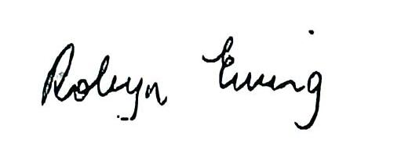

Robyn Ewing
ALEA President

