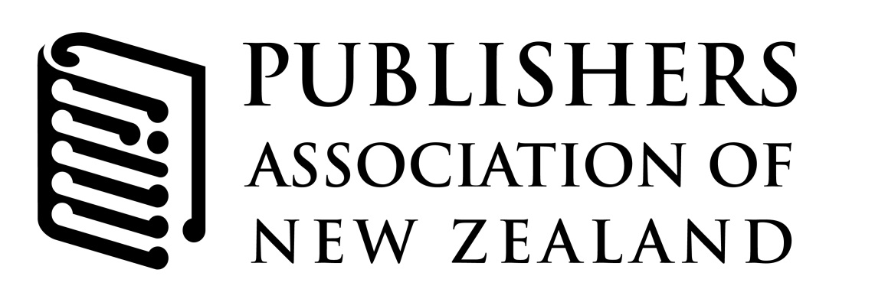
Sam Elworthy, President
Anne de Lautour, Association Director
4 Whetu Place, Mairangi Bay
Auckland 0632
P O Box 102 006, North Shore 0745
New Zealand

admin@publishers.org.nz
+64-9-477-5589
+64-9-477-5570
www.publishers.org.nz

COPYRIGHT IN THE DIGITAL ECONOMY. AUSTRALIAN LAW REFORM COMMISSION (ALRC) DISCUSSION PAPER
Submission from The Publishers Association of New Zealand
30 July 2013

The Publishers Association of New Zealand (PANZ) represents New Zealand’s publishing community, almost 100 publishers operating in this country—local and international, trade and educational, big and small, print and digital, children’s and adult. New Zealand publishers produce with their authors thousands of titles every year that are bought in bookshops, used in classrooms to educate students, and exported around the globe to tell New Zealand stories to our people and the world.

Copyright is the cornerstone of that work. Copyright recognises the value to society of creative work and the necessity of providing a law that ensures payment to creators so that they continue creating. Copyright law creates a marketplace for people to purchase copyright material for particular uses and recognises in fair dealing the exceptions to copyright under which some uses are allowed without permission.

It is very disappointing, therefore, to see the ALRC discussion paper propose a series of measures that will undermine copyright, reduce the revenue of publishers and authors and choke the ability of Australians to tell their own stories. The result will be less educational content, fewer great Australian histories, fewer authors willing to take on the big topics and less publishers willing to publish them. It is significant that EVERY recommendation of the commission favours the interests of online aggregators, social media companies and libraries and harms the interests of those who actually produce creative work. We can only assume that this is a conscious policy, but if so it is in our opinion a very unwise one.

Copyright businesses contribute 6.6% to Australia’s GDP and 8% of employment, contributing AUD 93.2 billion p/a to the Australian economy. Copyright businesses enable Australians, like New Zealanders, to tell their own stories in print as well as in new and exciting ways in the digital economy. The Publishers Association of New Zealand (PANZ) encourages the ALRC to propose a legal framework that supports the flourishing of creativity.

Specific Proposals

- Proposal 4-1: Fair Use
Like the UK and New Zealand, Australia has a long history of law and practice around fair dealing exceptions. Publishers are big users of fair dealing exceptions—they allow us to use many of the quotes and other materials we include in books—and we are comfortable working in an environment where certain, clear uses of copyright material are allowed under the act where they do not take the substantive work, do not cause commercial harm, etc.

The commission proposes changing fair dealing to fair use. And it proposes adding two new exceptions for education (proposal 13-1) and private and domestic use (Proposal 9-1). We oppose these moves because:

-fair use, as Lawrence Lessig wrote, just gives you the right to hire a lawyer. Introducing a less clearly defined exception will lead to years of legal costs falling on those whose material is taken—copyright owners.

-fair use plus specific educational exception will lead to the end of students and educational institutions paying for using chapters from books in coursepacks, despite the importance of that market for publishers and the availability of efficient licensing for such works. That is clear from the Cambridge University Press et al. v. Patton et al and Alberta (Education) v Canadian Copyright Licensing Agency (Access Copyright). For Australia to follow that lead is purposively destructive of educational publishing.

- Proposal 6-1: End statutory license
Statutory licences are an efficient way, used around the world under the auspices of International Federation of Reproduction Rights Organisations (IFRRO), for educational institutions to use copyright content legally through the paying of a reasonable license fee. Educational institutions universally use work from a diverse range of publishers—in our case, not just 100 local publishers but from thousands of publishers from countries around the world. Individually licensing each chapter before copying to a class would be very costly and inefficient. In Australia, CAL offer a clear, transparent, affordable license. To pull apart that system which has served Australia well would mean less income to publishers and more time and money spent by educational institutions tracking down copyright owners to pay.

We hope that these suggestions are useful. We call on the ALRC to rethink its proposals and we would welcome discussing any details with the Commissioners.

Regards
Sam Elworthy
President
Publishers Association of New Zealand

