CONTENT CREATOR SUBMISSION LETTER TO THE ALRC REVIEW OF COPYRIGHT AND THE DIGITAL ECONOMY – Education Statutory Licence Focus

I am an author who creates content for a living.
I develop something from nothing using my time, creative skills and knowledge and my material is my intellectual property. I own the copyright in my material and I expect people who use it pay for the time and effort I have expended on my creation. Not only do I expect to be paid but I rely on that payment for my income.
The statutory licences that the ALRC is recommending be repealed are very important to me. If my work is copied and shared by teachers in the classroom, I receive a copyright payment from the Copyright Agency.
These payments are recognition of the value of the material I have created, using my time, skill and experience. Just as a supplier sells paper to a school for use in a photocopier – or a retailer sells laptops to a school, my work facilitates education.
The system works very efficiently and quietly with very little administrative requirement from me. However, should the change proposed be made, how will I develop licensing arrangements myself? How will I track down copyright breaches? How will I prosecute breaches? How will I afford to mount a legal case? What compensation will I get for loss of income; to mount legal challenges or for the time it takes me to administer licensing arrangements?
I am a specialist in my field; I have little expertise in the intricacies of copyright law, nor the time to pursue breaches – no matter how concerned I am.
I completely reject the repeal of the very effective and fair Australian educational statutory licence system. Such a recommendation is a personal attack on my rights.
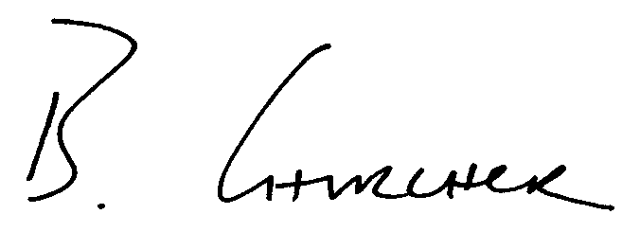
Ben Churcher
Director

