**431._org_Professional Teaching Council of Western Australia**

**PROFESSIONAL TEACHING COUNCIL OF WESTERN AUSTRALIA** [*www.ptcwa.wa.edu.au*](http://www.ptcwa.wa.edu.au)

PTCWA

PO Box 196

MT HAWTHORN WA 6915

Australian Law Reform Commission

GPO Box 3708  
Sydney NSW 2001

To whom it may concern

The Professional Teaching Council of Western Australia (PTCWA) is the peak body representing voluntary professional education associations within Western Australia. As an umbrella body representing individual associations, PTCWA represents over 9,000 teachers across all sectors and all learning areas.

The Professional Teaching Council of Western Australia (PTCWA) is concerned about the proposed changes to the copyright system currently being used by our teacher members. The Educational Statutory Licence system which is in use at the present time, offers fair remuneration to the people who create high-quality Australian educational resources and allows our teacher members to copy and share material, for about a quarter of the commercial cost of a textbook.

We understand a recommendation has been made to remove the current system and replace it with a combination of new arrangements. Any changes to the current system will create a further burden to our already time-poor educationalists and could result in the delivery of a less than superior learning experience for students.

PTCWA strongly opposes any change to the current system that creates uncertainty about what our teacher members can and cannot share with their students.

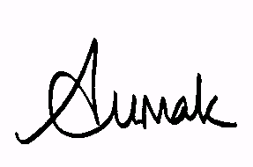

Yours sincerely

Anne Tumak

President

Mobile: 0417 917 470

21st July 2013