Cengage Learning Australia Pty Limited
Level 7, 80 Dorcas Street
South Melbourne VIC 3205 Australia
Tel: 61-3-9685-4111 Fax: 61-3-9685-4199
ABN 14 058 280 149 ACN 058 280 149

15 July 2013

TO: Australian Law Reform Commission
RE: ‘Copyright and the Digital Economy’ – Discussion Paper 79

Cengage Learning Australia Pty Ltd (CLA) has a long history in publishing local textbooks, and student & teacher resource materials in Australia. CLA specific serves the Education market, with strong annual frontlist publishing for the primary, secondary and tertiary market segments and maintains a considerable title portfolio of backlist resources in both print and multi-platform digital formats for each of these three market segments.

All our key titles are available in digital interactive format in addition to print. A host of other digital assets are continually invested in and created by Cengage to supplement and expand our main resources for the learning advantage to students in each of the education sectors we operate in.

This submission is a follow up to our 8th Nov 2012 submission to the ALRC and specifically in response to the Discussion Paper 79 issued in June 2013 by the Australian Law Reform Commission.

In our opinion, there are two critically inaccurate contentions made by the Commission that are absolutely fundamental to this discussion, and which seriously question the ALRC’s understanding on how the Education market in Australia actually operates – how students learn and how teachers teach with respect to the provision of bespoke commercially produced teaching and learning resources.

Fundamental inaccuracy number 1: That somehow Voluntary licences will be more efficient.

At section 6. Statutory Licences, para 6.3 states “Voluntary licences – whether direct or collective – are less prescriptive, more efficient and better suited to a digital age”. As a consequence of this section proposal 6-1 states “The statutory licencing schemes in pts VA, VB and VII div 2 of the Copyright Act should be repealed” ......and ...”should instead be negotiated voluntarily”.

- Facts – per Australian Bureau of Statistics. There are currently 260,000+ practicing teachers working in over 9,000+ Australian schools. Under the existing Statutory licence not one of these 260,000+ teachers who ‘stand by’ photocopy machines and collectively copy over 900,000,000 pages of copyrighted published materials every year have to seek even a single permission request.

Higher education and tertiary students and academics also access tertiary content in a similar method.

- To therefore boldly state that voluntary licencing will be more efficient simply can’t be supported. There will firstly need to be hundreds of separate voluntary licences negotiated by each and every education institution. Teachers and academics will need to internally check whether the material they intend to copy is covered and if not - seek a licence with the intellectual property owner. Teachers and academics will have to determine whether the material is sufficiently covered or not under whatever ‘fair use’ tests are legislated. All of this can only be far more time-consuming and burdensome on teachers and teaching administration – time that can only be taken from classroom teaching, classroom lesson planning and student work assessment. Does Australia want even more administration time performed by teachers and academics!? Already the equivalent of at least 2,000 fulltime teachers each year is spent just photocopying paper of published works in schools alone.

Fundamental inaccuracy number 2: That somehow Voluntary licences are better suited to the digital age.

- The photocopying of nearly one billion pages of printed material forms the substantial majority (94%) of the Statutory licence annual fees paid to CAL and administered on behalf of IP owners. This has nothing to do with a digital age. It is just photocopying paper, an activity that has been occurring in substantial quantity for decades – well before digital content, before tablets, before the internet, before PCs. Photocopying is widespread and is often undertaken as a budgetary substitute to buying the printed material. To make the recommendation that the Statutory licence scheme (which deals over 90% with non-digital activities) should be repealed given the remit of the ALRC is ‘Copyright and the Digital Economy’ is completely facile and illogical.

- By all means the ALRC can make a case on voluntary licencing of digital content downloaded from websites or displayed electronically on classroom devices such as whiteboards and PCs. But such voluntary licencing (of copyright digital content use) should be quarantined to the 6% of the current statutory licence that relates to and remunerates IP owners for this digital use. Do not confuse the photocopying of printed materials to somehow make a case to dismantle the hugely efficient statutory licence which has so admirably served the industry – IP owners and users, - (some 260,000 teachers and 3,500,000 students in Australia).

No one is questioning that the market landscape with regard to the use of technology in Education has changed rapidly over the last 10 years. That both hardware and software developments have enabled content to be shared more easily, be copied, transferred, stored and edited for use in a classroom and education setting should not be a reason why the intellectual property rights of the creators/owners of said education content should now be compromised and diluted in the level of remuneration otherwise available to them.

Education content is created specifically for Australian curriculums by subject, and by year level. It is always written in age appropriate language and concepts are meticulously developed using Australian examples and context wherever relevant. Revenue source from this commercial activity is twofold – normal transaction sale, and CAL statutory licence distributions (mostly from photocopying our work rather than purchasing it). Our content is not purchased by impulse, given as a gift, or used as a rollicking good read on a plane. It cannot include advertising, we cannot sell customer names, employ pop-up and click-through marketing to children, or have some allied merchandising associated with it.

If we diminish the total revenue pool from the creation of quality curriculum based resources for Australian students – then we simply create less and less quality and relevant education content as a consequence. It is, in our opinion as a long standing specialist education publisher, simple cause and effect.

I hope this submission enables the ALRC to form a better and balanced understanding of educational publishing and the key copyright issues that we focus on, particularly in relation to digital content development and digital delivery to our customers and end users.

Yours sincerely,

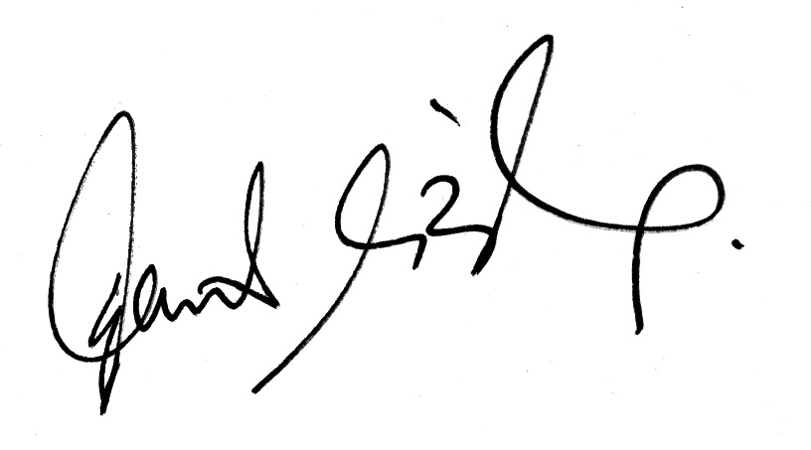

David O’Brien
Vice President – Schools
Cengage Learning Australia

