The Executive Director
Australian Law Reform Commission
GPO Box 3708
Sydney NSW 2001
Email: privacy@alrc.gov.au
Submission to the issues paper on Serious Invasions of Privacy in the Digital Era
IP43 October 2013
Dear Commissioner,
The Australian Institute of Professional Photography (AIPP), with a history of nearly 50 years in the photographic industry, is Australia’s leading membership body for the professional photographic community, with over 3000 Members around Australia. We actively support professional image-makers at all stages of their careers. We are also in regular communication with the broader community of photographers (both amateur and professional) who are not members, and we have strong affiliations with similar professional organizations in Asia, the US and Europe.
Privacy issues are a constant and difficult issue for commercial photographers and we can draw on plenty of anecdotal evidence of problems that occur with our members in this regard. We are often put in the same category as a security surveillance operation – the public perception of our industry is often way off beam.
Commercial photographers have a legitimate interest in how any potential privacy legislation would be framed, the viability of a creative industry like photography is constantly under threat, over bearing legislation and regulations can make this even more difficult and our society is then deprived of a photographers eye that documents the world we live in for future generations to see.
Point 2 of the attorneys scope of reference “ The necessity of balancing the value of privacy with other fundamental values including freedom of expression and open justice” is fundamental to our concerns that the possibility of broad brush privacy law is introduced in Australia. We would therefore welcome any opportunity to meet with the commission to discuss privacy in general terms or if there are any particular privacy issues you would like to discuss specifically to do with photography, we would be happy to meet with Commission staff at any time.
As a principally volunteer-run organisation, our resources are limited in terms of getting expert advice on constitutional, legal and legislative issues, so we rely heavily on organizations like the Arts Law Centre of Australia (Arts Law) to deal with the complexity of these issues as they arise. We only became aware of this enquiry some weeks ago and have not been in a position to develop a detailed formal response to the issues paper on our own. We have however been in close communication with Arts Law over the last few weeks and have had some input into their detailed response.
We therefore strongly support the position that Arts Law have presented.
We would encourage the ALRC to seek a meeting with us prior to the final report being delivered to the Attorney General by June 2014

Yours faithfully
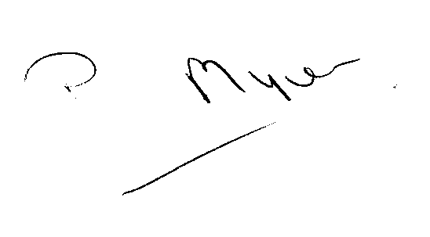
PETER MYERS
AIPP EXECUTIVE OFFICER

