Legal Barriers for People with a Disability

Submission to the Australian Law Reform Commission

Deaf Society of New South Wales
January 2014

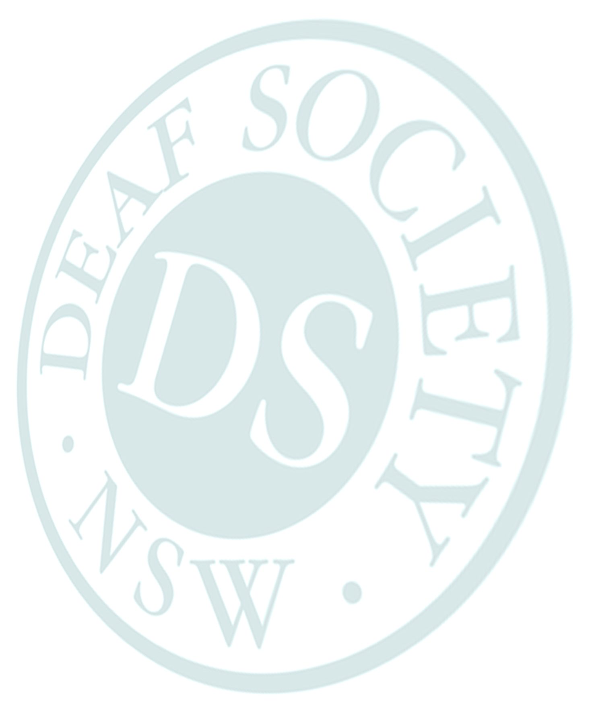

Contact
Sharon Everson
Chief Executive Officer
Deaf Society of New South Wales
severson@deafsociety.com
ph. (02) 8833 3600
fax. (02) 8833 3699

Contents
Background 3
Executive Summary 4
Recommendations 4
Making Complaints under the Disability Discrimination Act 1992 (DDA) 4
Language Rights Protection 5
Definitions of CALD Groups 7
Language Rights in Health Settings 7
References 7

Background
The Deaf Society of NSW was established in 1913 and is a company limited by guarantee. We are a not-for-profit, bi-lingual, bi-cultural, community-centred organisation which exists to achieve equity for deaf people. Our services include employment services, Auslan interpreting, education and training, independent living skills, advocacy, community development and community services. Our vision is Equity for Deaf People. We work in partnership with the Deaf Community to enhance the quality of life of deaf people, strengthen the community and advocate for changes that will ensure fundamental rights and freedoms.

As a disability service organisation, we do not offer technical legal information but rather outline some of
our experiences of the barriers faced by deaf people and make general recommendations about the directions of the reform needed to remove those barriers.

In this submission, we refer to the Deaf Community as both a disability group (because members of the community have their rights protected under the UNCRPD), and a CALD group (because the community has a unique language, Auslan, and a unique set of cultural practices and values which are quite different to the practices and values of the wider community). Hard of hearing people are those with a hearing loss who use a spoken language as their main means of face-to-face communication and who do not identify with the Deaf Community. Deafblind people have both hearing and vision loss, and may communicate in English or Auslan or both, using adapted visual, auditory, and/or tactile modes.

The Deaf Society of NSW greatly appreciates this opportunity to provide a submission to the Australian Law Reform Commission.

Executive Summary
The Deaf Society of NSW has witnessed or worked with stakeholders who have experienced many instances of discrimination or disadvantage on the basis of being deaf. These experiences could be avoided in future by introducing reforms to Commonwealth Law in the areas of:

- Barriers to making complaints under the Disability Discrimination Act 1992 (DDA),
- A lack of clarity surrounding the ‘unjustifiable hardship’ provision in the DDA,
- A lack of language rights protection,
- The definition of the term “culturally and linguistically diverse (CALD)” in law and policy, and
- The timeliness of access provisions in public health settings.

Our general recommendations about the reforms required are made below.

Recommendations
Recommendation 1
That organisations be allowed to make complaints under the DDA where the alleged discriminatory conduct relates to the aims of the defending organisation, or where a significant percentage of the membership of the organisation making a claim is affected (see PIAC, 2012).

Recommendation 2
That the unjustifiable hardship provision be tightened and clarified to prevent it continuing as a loophole for organisations who wish to avoid the costs of making their services accessible.

Recommendation 3
That the language rights of deaf children and adults, as set out in the UNCRPD, be protected in Australian Commonwealth Law.

Recommendation 4
Where Commonwealth Laws refer to culturally and linguistically diverse (CALD) groups, it is recommended that deaf people be explicitly included in the definitions of those groups.

Recommendation 5
That Commonwealth Laws relating to access to public health services be strengthened with clearer guidelines about timeliness of access.

Making Complaints under the Disability Discrimination Act 1992 (DDA)
Although the DDA provides nominal protections of human rights, there remains the serious problem of enforcement. Organisations which engage in discriminatory conduct appear to do so with relative impunity, both because of the restrictions on who can make complaints, and because of the looseness of the ‘unjustifiable hardship’ provision.

As organisations are unable to bring complaints, it is difficult to effect systemic change. We know where problems exist, but are unable to take action through legal channels on behalf of stakeholders. It is therefore difficult to address barriers on the systemic level. This particularly affects the realisation of human rights for deaf people in access to areas such as education where a large number of people accept poor access for many years before someone with time, energy and courage makes a complaint.

It must be remembered that deaf people who experience discrimination are very often already disadvantaged by circumstances such as:

- poor education,
- unemployment,
- precarious housing arrangements,
- mental illness,
- lack of English literacy,
- lack of legal literacy,
- lack of understanding of institutional structures and process, and/or
- poor understanding of their own rights as citizens.

In most cases it is simply not reasonable to expect that deaf people experiencing discrimination will have the time, resources, determination or support to make individual complaints. In our experience, only a tiny percentage of deaf people who experience discrimination actually do so.

The unjustifiable hardship provision for organisations seeking to avoid paying for access measures such as Auslan interpreters or real time captions needs to be clarified and tightened so that it does not remain the loophole which it currently is.

Case Study
Kate* is a professional who was seeking to complete a short course at a training provider which was part of a larger education institution. The training provider refused to pay the full cost of Auslan interpreting for the short course on the basis that it would unreasonably disadvantage them. The larger educational institution provides disability support to access their courses, but Kate was unlikely to be eligible for this support.

On the basis of the law as it stands, legal advice to Kate stated that a claim under the DDA had no reasonable prospect of success. It appeared that the claim of unjustifiable hardship would be likely to be upheld on the basis of the impact of interpreting costs on that one course alone, without reference to the financial position of the training provider or of the larger educational institution of which it was a part.

Kate did not attend the course and did not pursue a complaint.

*name and details changed to protect identity

It appears that the unjustifiable hardship claim in this case was interpreted with reference only to individual courses, rather than with reference to the financial position of organisations as a whole. Of course it is reasonable that providers do not wish to run courses at a loss (and may even cancel them if there is a prospect of this happening), but this effectively bars deaf people from participating in most small courses, at any training provider, whether small or large. The law needs to be reformed so that deaf people’s rights under the CRPD are realised.

Recommendation 1
That organisations be allowed to make complaints under the DDA where the alleged discriminatory conduct relates to the aims of the defending organisation, or where a significant percentage of the membership of the organisation making a claim is affected (see PIAC, 2012).

Recommendation 2
That the unjustifiable hardship provision be tightened and clarified to prevent it continuing as a loophole for organisations who wish to avoid the costs of making their services accessible.

Language Rights Protection
The UNCRPD provides protections for the rights of deaf children and adults to learn and use sign language (see Articles 9.2.e, 21.b, 21.e, 24.3.b, 24.4, and 30.4). For example, the convention obliges States Parties to “facilitate[e] the learning of sign language and the promotion of the linguistic identity of the deaf community” (Article 24.3.b). The use of sign language in education and especially in early education is particularly critical, because the denial of sign language to deaf children in early life can have long-lasting and severe effects on academic, health, and psycho-social outcomes.

Case Study: Tom*
Child who acquires language late due to lack of signing early intervention.

Tom was first diagnosed with hearing loss after failing his SWISH test and was referred for further assessments at another hospital which confirmed a profound hearing loss complicated by Auditory Neuropathy (ANSD). Tom was given hearing aids whilst they were trying to determine his hearing threshold but this process was long as his hearing fluctuated due to the Auditory Neuropathy. The itinerant support and early intervention service had little understanding of ANSD and did not realise that traditional testing would not give a clear picture of Tom’s hearing loss which led to a delay in his receiving a cochlear implant. By the time he was implanted he was two and half years old and had delayed communication. Tom’s itinerant support teacher and early intervention service were also unaware of the need for sign language and lots of visual supports in order to help the development of Tom’s language.

Tom has had progress after implantation and can hear very well but his ability to understand what he is hearing has been severely impacted. He has struggled so badly that SCIC (Sydney Cochlear Implant Centre) and RIDBC (Royal Institute for Deaf and Blind Children) has recommended sign support in order to give him a better understanding of what he is hearing. The Roberta Reid Centre which is a preschool that provides instruction in Auslan told his mother that Tom would require six hours of therapy five days a week. As his mother was also learning Auslan herself it was not appropriate that she teach him and he therefore needed someone that was much more experienced in the language.

Tom’s mother then visited his preschool to see whether there was some funding that could be used to employ a sign support teacher. She was told that they had already accessed a teacher’s aide for the classroom to help support Tom (and other students) so that the most he could get would be three hours extra.

His mother has taken Tom out of pre-school as she has observed that he is not able to defend himself with other children by using words so is vulnerable to accidents and bullying.

Tom is a preschool aged child who cannot defend himself using language in the playground with other children. He has a significant language delay due to a system that does not enable or support him or his family to access Auslan in a timely manner and delaying access so that other interventions that rely on spoken language, which is viewed more favourably than sign language, can be tried first.

*name and details changed to protect privacy

Nowhere in Commonwealth Law do the language rights of deaf people or deaf children appear to be explicitly protected. We note with concern that:

- some states (such as NSW) lack any signing early intervention programs,
- parents are still routinely given misguided advice by health professionals not to sign with their deaf child due to a fear that it will interfere with spoken language development when the research clearly shows this is not the case and can in fact enhance language development,
- parents are still routinely asked to make a “choice” between signing and speaking methods of education before their deaf child has begun to learn either language,
- some state education departments (such as NSW) do not provide qualified interpreters in the classroom for children who are accessing the curriculum in Auslan,
- teachers of the deaf teaching children who use Auslan are not required to have any minimum standard of competence in the language,
- information in Auslan is not routinely provided on government websites, and
- deaf people lack access to interpreters in private legal settings and a range of other situations.

Recommendation 3
That the language rights of deaf children and adults, as set out in the UNCRPD, be protected in Australian Commonwealth Law.

Definitions of CALD Groups
As noted in the Issues Paper (p. 90), there are particular issues faced by CALD people with a disability. Deaf people are unique in that deafness, although generally understood as a disability, gives rise to a culturally and linguistically diverse status. Deaf people, like other people from CALD backgrounds, face language and accessibility barriers, stigma, and a lack of willingness to engage with complaint mechanisms. They also have difficulty accessing interpreters and culturally safe spaces where they can ask for and receive accessible information in Auslan. There are concerns that the introduction of the NDIS could lead to the reduction of state-funded information and advocacy services.

To add to all of these difficulties, deaf people are not always recognised in law or policy as a CALD group, further perpetuating the perception of deafness as a disability only, and leading to inadequate or inappropriate interventions. Although it is also appropriate to class deafness as a disability, it is often more helpful from a policy point of view to define deafness as cultural and linguistic diversity, because it can then give rise to more appropriate interventions. For example, a deaf child in a school, treated as a person with a disability, may be provided with a Teacher’s Aide (unqualified in sign language), when it would be more appropriate to recognise that the child is CALD and to provide them with a qualified interpreter.

Recommendation 4
Where Commonwealth Laws refer to culturally and linguistically diverse (CALD) groups, it is recommended that deaf people be explicitly included in the definitions of those groups.

Language Rights in Health Settings
Deaf people face barriers to timely access to appropriately qualified interpreters in public health care settings. Although this right is currently protected in theory, in practice deaf people can face long and potentially life-threatening waits for interpreting services, or even undergo treatment without interpreters being present to explain procedures.

Recommendation 5
That Commonwealth Laws relating to access to public health services be strengthened with clearer guidelines about timeliness of access.

References
Public Interest Advocacy Centre, 'Aligning the Pieces', 21 December 2012 (http://www.piac.asn.au/sites/default/files/publications/extras/12.12.21_aligning_the_pieces_-_submission_to_the_senate_legal_and_constitutional_affairs_committee_-_human_rights_and_anti-discrimination_bill_2012_0.pdf accessed 11/12/2013)

