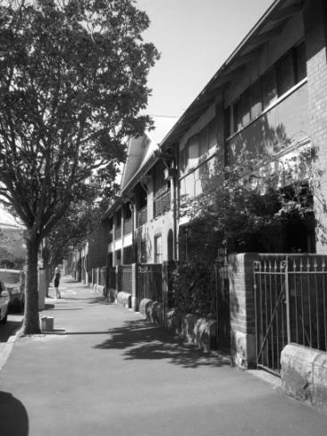
The Millers Point Community Working Party
Representing
- The Millers Point, Dawes Point, The Rocks and Walsh Bay Resident Action Group

- The Millers Point, Dawes Point & the Rocks Public Housing Tenants’ Group

The Millers Point Community Working Party

Submission on Elder Abuse in NSW

Submission on Elder Abuse in NSW

- Introduction
The Community Working Party is the umbrella body for the Millers Point, Dawes Point, The Rocks and Walsh Bay Resident Action Group (RAG) and the Millers Point, Dawes Point and The Rocks Public Housing Tenants Group (PHTG). The Millers Point Community Working Party was formed by the combination of the Residents Action Group and the Public Housing Tenants Group to represent the interests of the tenants, especially, the social and public housing tenants during our time of turmoil as the forced relocation process was instigated.

Note that in this document reference to “Millers Point” means Millers Point, Dawes Point and The Rocks in this context.

The Australian Law Reform Commission has been directed to conduct an inquiry into elder abuse with the emphasis on promoting and supporting older people's ability to participate equally in their community, to have access to services and advice, and, to provide specific protections against elder abuse.

- Elder Abuse
How is elder abuse defined? A government policy in itself may constitute a form of elder abuse such as what we have and are still witnessing in Millers Point due to the forced relocation of older tenants, many of whom are enduring psychological abuse, by not knowing when and where they would be moved!

Could this be classified as an example of systemic abuse?

- Social Impact
Prior to the NSW Government’s decision to sell its housing stock in Millers Point, they commissioned Cred Community Planning to undertake a Social Impact Assessment. This report found that negative health and well-being outcomes for residents with long term or generational connections to the area was clearly noted through engagement within the community and other social research ie:

- Stress of leaving,
- Loss of existing social networks and local services,
- Anxiety in trying to establish new social connections in a new community, and
- Inability to cope with hardship, leaving older tenants feeling insecure.
- Impact of Lack of Policy
The NSW Government has an 'Ageing Strategy' and does not specifically refer to 'ageing in place' although this is mentioned in a number of significant documents commissioned by them.

Being part of the Millers Point community was very important for older tenants’ general and mental health and, the forced relocation process seems to be a traumatic and sad change bringing with it stress, a sense of loss and worse, tragedy!

There has been a dramatic rise in hospitalisations, illnesses, serious injury and sadly fatalities! All predicted!

We have seen FACS/Housing promote stories of happy relocated tenants. However, many former and remaining tenants are far from happy with their experiences. This is highlighted in a report by Professor Alan Morris, Institute for Public Policy and Governance, University of Technology, Sydney. Titled
'A contemporary forced urban removal: The displacement of public housing residents from Millers Point, Dawes Point and the Sirius Building by the New South Wales Government' where tenants tell their stories and it concludes:

'What is evident is that the actual and intended removal of public housing residents from Millers Point unleashed a great deal of hardship and distress.
In sum, the way the New South Wales government has gone about the move was viewed as brutal. ...The announcement that all residents were to be moved was catastrophic for some residents and precipitated extreme anxiety and depression.'

- The Critical Need for Elderly Abuse and Ageing in Pace to be Addressed in Legislation
Therefore we ask that the Australian Law Reform Committee recognises the systemic elder abuse of older residents in Millers Point and that the New South Wales Government does not run the risk of repeating the mistakes made in Millers Point by denying older tenants the right to 'age in place' with the possible consequence of what can only be described as institutionalised elder abuse!

Marcia Chalmers
Secretary
For and on behalf of the Millers Point Community Working Party

