Thursday, 26th Feb 2015

The Hon. George Brandis QC
Attorney General of Australia
Australian Law Reform Commission

Dear Sir,

I enclose my submission for your inquiry into identification of Commonwealth Laws that encroach upon traditional rights, freedoms and privileges.

I wish for you to investigate the following Government Bodies and Acts which certainly do encroach on the traditional rights, freedoms and privileges of myself, my children and millions around Australia and the world. It is in regard to the extremely high levels of radiation we are exposed to via wireless technology, the serious health risks involved and the way it prevents those affected from leading normal lives. Where something that is a fundamental Human Right such as the opportunity to go to school, is no longer an option for my children due to wireless technology.

- Australian Radiation Protection and Nuclear Safety Agency - ARPANSA’S Radiation Standard RPS3 and Maximum Limits – which do not protect the Health of Humanity, especially children and people who are already suffering sensitivity to the current high levels of radiation exposure.
- The federal Radiocommunications act and the Human Exposure Standard (under which ARPANSA Standards are set).
- The telecommunications Act – which allows Mobile Phone Masts/Base Towers to be placed anywhere, even close to schools and homes, with no regard for the health of those in close proximity.
- The NBN Co. Act – which is allowing fixed Wireless.
- ACMA - Australian Communications and Media Authority
There are millions of people world wide that are suffering adverse side effects from exposure to radiation from wireless technology. Among them are many Australians, such as myself and my children, whose lives have been severely affected, and whose human rights have been taken away.
I can no longer work due to my symptoms. Both my children were forced to leave mainstream schooling and start Distance Education from home, as being at school with Wi Fi and iPads made them feel extremely ill and affected their ability to concentrate. As a result my children have lost touch with all their school friends and are quite isolated.
We are very restricted in our every day lives. This means that going to see a live show, the theatre, a wedding, a funeral, visiting loved ones in hospital, going to shops, visiting friends, and sadly, even attending SCHOOL – is something my children and I cannot do.
Like many others in our situation, we have contacted ACMA, ARPANSA, the Dept. of Education, The Minister for Education, and received no help at all. ARPANSA do not wish to accept accountability and directed us to ACMA. ACMA do not wish to accept accountability and directed us back to ARPANSA. The dept. of Education buried its head in the sand and simply ignored our request for help. The telecommunication companies and Dept. of education hide behind ARPANSA’S Standards.
Here are the major points I urge you to consider in your investigation:

- ACMA/ARPANSA cannot prove that exposure to wireless technology is SAFE. Especially with the current Safety Standard which is way too high. Yet they will not accept accountability for the health and safety concerns repeatedly brought to their attention by the public.
- ACMA/ARPANSA have in fact reversed the burden of proof on to us – the very people who are being adversely affected by the Standards “they” have set. We did not create this technology, nor the current safety standards. We are being forced into being exposed to this radiation.
- Children do not have a choice in regards to attending school. Children depend on the adults and decision makers to keep them safe. Exposing them daily to this harmful level of radiation via school wi fi is a breach of the school’s duty of care, Human/Children’s rights and Disability Discrimination.
- The Principal at my children’s school did not attempt to accommodate their special needs in any way. He told me to “Distance ed” them. End of story. This was Disability Discrimination not to mention, heartless and heartbreaking. My children’s rights were taken away from them by the school, and the govt. bodies associated with wireless technology.
- Schools abide by the ARPANSA Standard, which does not protect children (they absorb radiation at a far greater rate than adults and also were not considered in the decision making/testing for safety standards).
- There are many peer reviewed scientific papers and research available, that clearly show that wireless technology poses a threat to our health and safety.
- The World Health Organisation has reclassified radio Frequency Electromagnetic Radiation as a possible Class 2B Carcinogen. http://www.iarc.fr/en/media-centre/pr/2011/pdfs/pr208_E.pdf
- Many countries in Europe have adopted “The Precautionary Principle” and are protecting their young and communities by hardwiring the computers in schools and libraries. They also have Wi Fi free locations. http://www.euro.who.int/__data/assets/pdf_file/0003/91173/E83079.pdf
- Hardwiring computers actually gives superior internet connection. Wi Fi is NOT required to connect to the internet – therefore not a necessity to run a curriculum at schools. iPads are not the high tech learning solution first thought to be. They not only distract students, but also harm their health.

- Telecommunication companies cannot get insurance due to the uncertainty surrounding the safety of their products.

- Communities are crying out for reforms of the safety standards and regulations. Let’s follow Europe’s example and make changes for the better.

We urge you to help keep Australians safe. The current level of exposure to Wireless radiation is a clear breach of Human Rights laws, Disability Discrimination Laws, and Occupational health and safety Laws.
The lives and futures of our youth and communities rely on updating the Safety Standards, and educating our communities on how to live safely with technology, in order to avoid a serious health crisis.

Thank you for taking the time to consider my submission to your inquiry. I leave you with a quote from Albert Einstein:

“ Concern for man and his fate must always form the chief interest of all technical endeavours. Never forget this in the midst of your diagrams and equations”.

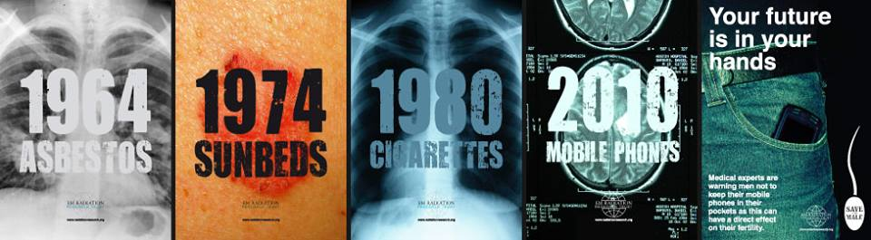

Yours Sincerely,

Patricia Garcia

