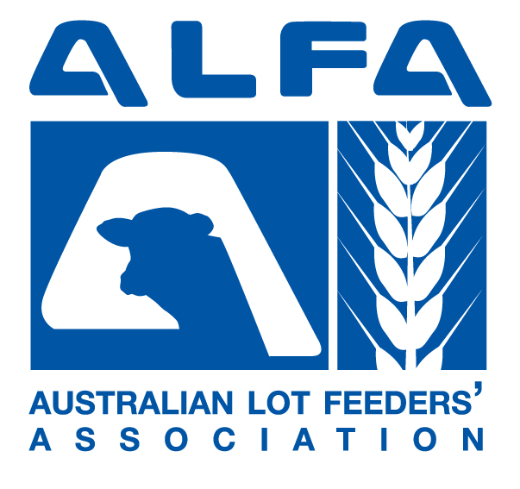

Response to the Australian Law Reform Commission inquiry into Serious Invasions of Privacy
In the Digital era

November 2013

AUSTRALIAN LOT FEEDERS' ASSOCIATION (ALFA)
Level 5, 131 Clarence St Sydney NSW 2000

Background

The Australian Lot Feeders’ Association (ALFA) appreciates the opportunity to respond to the Australian Law Reform Commission (ALRC) inquiry into serious invasions of privacy in the digital era.

ALFA is the peak representative body for the cattle feedlot industry. The industry has a value of production of approximately $2.7billion and employs some 9000 people directly and indirectly. Approximately 25% of Australia’s total beef supply, 80% of beef sold in domestic supermarkets and the majority of beef industry growth over the last 15 years has been due to the expanding feedlot sector.

There are approximately 400 accredited feedlots in Australia located in areas that are in close proximity to cattle, grain, water and beef processing facilities. The majority of feedlots are located in Queensland followed by NSW, WA and then Victoria and South Australia.

Around 98% of feedlots are owned and managed by Australian families.

The location, number and size of feedlots throughout Australia
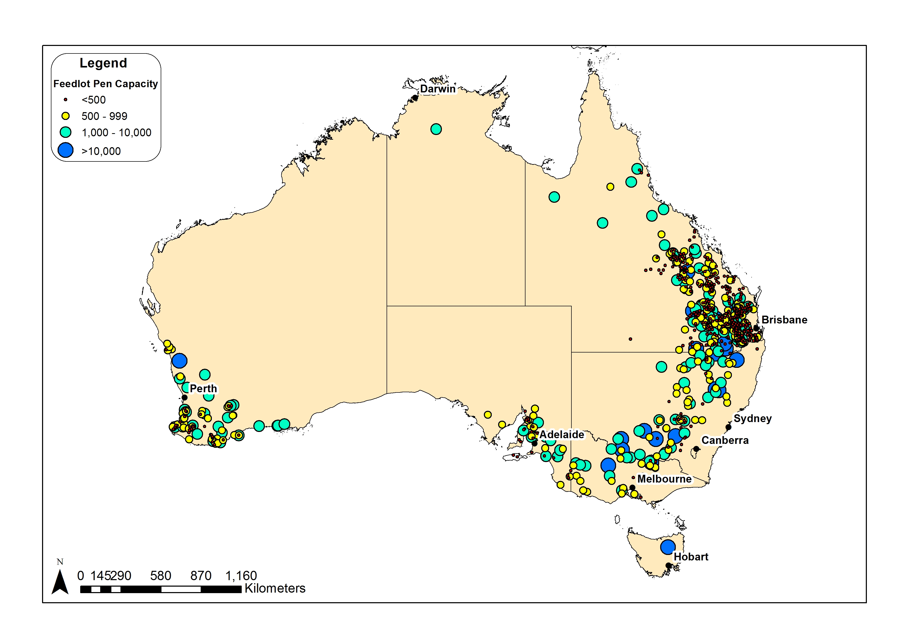
Comments in relation to the inquiry

ALFA’s concerns in relation to this inquiry relate specifically to current state and federal privacy laws not keeping abreast of the increased availability and use of drone technology by civilians.

It is clear that advances in technology have had a marked impact on the privacy of individuals and businesses around the world. At the same time, consumers are demanding to know more about the provenance, ethics and sustainability of food production. Increasing awareness and concern about animal welfare is an important element of this trend.

The cattle feedlot industry has implemented a range of measures to demonstrate transparency, to continually improve industry practices and to address weaknesses if and when they become apparent. As a result of such actions, respected animal welfare organisations such as the RSPCA have declared their full support for the industry.

However, more radical groups such as Animal Liberation (who oppose all forms of animal production) pursue a much more militant agenda involving activities where privacy and trespass concerns are often ignored. The placement of video cameras in piggeries without the knowledge or consent of the owner is a case in point. Through such examples, Animal Liberation argues that the public interest overrides any private property rights that piggery owners may have.

The recent purchase of a drone by Animal Liberation to capture footage of intensive livestock farms similarly takes advantage of the inadequacies of current privacy and common law. As it currently stands, it is understood that there is no statutory cause of action under state or federal privacy and common law in relation to the use of drones fitted with surveillance cameras over private property. It is accordingly clear that current law has not kept up to date with advances in such technology and their transition from military to civilian application from a privacy context.

It is important to note that ALFA does not condone animal cruelty and does not shield those within our industry who have breached legislation in this area. In fact we actively promote increased transparency through the organisation of thousands of feedlot tours each year and the implementation of a quality assurance program which independently audits feedlots on an annual basis. We will also quickly inform authorities if we discover that a legislative breach by a rogue feedlot operator has occurred as we are highly aware of the potential reputational damage to the wider industry from such actions. It is through increased transparency and continual industry improvement that we believe will deliver consumer confidence in our sector over time.

We do not however support the unauthorised use of drones over feedlots when;
- Lot feeders have a demonstrated willingness to allow visitors onto their property to show and explain their feedlot and activities;
- Animal welfare legislation allows the RSPCA to enter feedlots if any animal welfare issue is suspected;
- The industry’s quality assurance program, the National Feedlot Accreditation Scheme allows independent auditors to enter accredited feedlots if any animal welfare issue is suspected;
- Drones may stress or cause injury to cattle by flying too close. Panicked cattle can run into fences and injure themselves if they are unduly stressed by objects that they see as unfamiliar. At this stage it is unknown whether civil aviation regulations regarding the use of drones above 30m in altitude is sufficient in this regard. If drone use does cause cattle stress or injury, this would not only result in outcomes that are directly in opposition to the intent of what animal activist groups are trying to achieve but would also lead to financial penalty to lot feeders as stressed cattle have inferior productivity and eating quality outcomes;
- The only individuals or groups who are likely to use drones over cattle feedlots are those which use them for unauthorised and malicious purposes. Specifically their deliberate intention is to deceptively obtain, selectively edit and utilise such footage to denigrate the reputation of the wider feedlot industry;
- Lot feeders are law abiding citizens whose have a right to be treated with dignity and the privacy of themselves and their property respected.

Statutory cause of action
Given the concerns detailed above, ALFA supports the introduction of a statutory cause of action for invasions of privacy involving the unauthorised use of drones over private property, particularly when footage is deceptively obtained and intended to be used for malicious purposes.

This requirement is also reinforced by the current failings of common law actions for trespass to provide an adequate deterrent to certain individuals. The Executive Director of the group Animal Liberation Mark Pearson for example, recently boasted on an ABC Landline episode, that he had been arrested and charged with trespass twelve times. It is accordingly apparent that the current penalties for trespass are not acting as a sufficient deterrent to those who wish to undertake such illegalities. As a result, ALFA would encourage the ALRC to explore whether appropriate deterrents could be addressed under privacy legislation.

Whilst the current discrepancies between state legislation lends weight to the argument in favour of the inclusion of such a cause of action within Commonwealth legislation, the fact that this statute is confined to individual privacy matters (and not also businesses less than $3million in turnover) is a weakness. Accordingly, ALFA would support the Commonwealth legislation extending to privacy matters for all businesses.

Privacy and the public interest
ALFA fully supports the right of the public to know that their food is produced in an ethical and sustainable manner. However, we believe that this is able to be achieved through a variety of current mechanisms without unauthorised drones being allowed to enter the airspace over private property. For example, the ability for the RSPCA to enter feedlots if any animal welfare issue is suspected should obviate any argument by animal activist groups that drones are required to gather footage over intensive livestock properties on the basis of public interest. Specifically, if such groups suspect animal welfare abuse, then they can notify the RSPCA and request an audit of the premises.

Harmonisation of state privacy legislation
As stated previously, ALFA supports efforts to harmonise privacy legislation across states given the current discrepancies.

Exemptions from statutory cause of action
Given the concerns detailed previously, we would oppose any request for animal activist groups to be exempt from a statutory cause of action for serious invasion of privacy.

Regulating aerial surveillance
ALFA contends that current legislation surrounding the use of drones were originally drafted with the intention of addressing safety surrounding commercial and private aircraft usage rather than privacy matters. This oversight and inadequacy now needs to be addressed.

Drones should not be permitted to be deliberately flown over private property if the intention is to obtain surveillance footage by deception and where the footage is to be used for malicious purposes.

